**840/2**

**INFORMATION AND**

**COMMUINICATIONS**

**TECHNOLOGY (ICT)**

**Paper 2**

**2024**

2½ hours



**UTEC MOCK EXAMINATIONS 2024**

**Uganda Certificate of Education**

INFORMATION AND COMMUINICATIONS TECHNOLOGY

**Paper 2**

Practical

2 hour 30 minutes

**INSTRUCTIONS TO CANDIDATES:**

*This paper consists of* **two** *examination items.*

*Answer* **both** *items in this paper.*

*You are provided with support files in the folder* **UTEC O_level Support Files 2024** *on the computer desktop. Use the support files where applicable to supplement the items.*

*You are provided with a* **new blank Compact Disc (CD)**. *Use a* **permanent marker** *to write your name, random number and personal number on your CD.*

*You should continuously* **save** *your work.*

*You* **must** *produce a* **hard copy** *for each of your work to accompany a soft copy on the Compact Disc* (*CD*).

**Turn Over**

**ITEM 1:**

Prom, short for promenade, is a semi-formal dance usually held toward the end of high school. It's a celebration and final send-off for graduating students before they embark on their next academic or life journey. In most Ugandan secondary school candidates organize farewell parties as a norm. The whole process starts from planning, organizing, budgeting and developing the activities of the day commonly known as the D-day’s programme.

 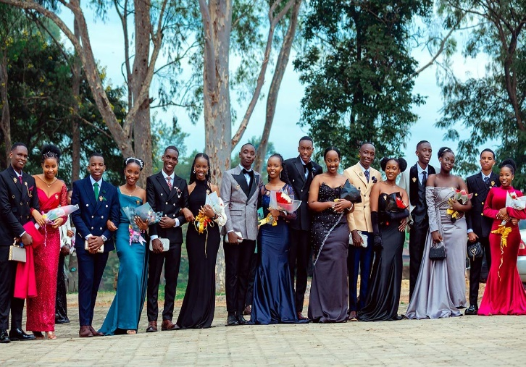

Source: <https://www.monitor.co.ug/uganda/news/national/the-changing-face-of-prom-in-secondary-schools-4623396>

Being one of the ICT student on the organizing committee, you have been ***tasked*** to;-

1. Prepare a budget for the party using the manuscript from the support file ***budget notes.jpeg*** to be presented to Chairperson Organizing committee for discussion in the next meeting. Save your file as ***Budget,*** use any suitable desktop application software of your choice.
2. Design invitation cards to be sent to important delegates to be invited to attend the function. Refer to support file delegates.doc for a list of names and contacts of important delegates to be invited. Save your file as ***Invitation,*** use any suitable desktop application software of your choice.

**ITEM 2**

The Uganda Electro Commission is planning to conduct LC 1 elections in the near future using an information management system to register voters, produce voter register forms, filter out eligible voters and present a general report to the public about the updated voters register. The manual register is provided to you in the support file ***register.doc***.

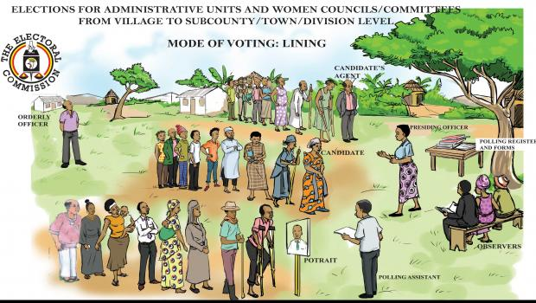

Source: https://www.google.com/

**Task:**

As one of the ICT enthusiasts, you have been requested to use any desktop data and information management system to help the electoral commission present the information contained in the support file above to the general public. It should be noted that voters a above 50 years of age shall not be eligible to vote and must be filtered/queried and displayed to public notice board.

Save your file as vote.

**END OF PAPER**